┍Brian's Corner
Club Website

8/5/15
T.R! (Telepresence Robot) v.0.2b


Since late 2013 I have been working on this robot that will soon be able to be able to walk and be controlled via tele-communications. As of now I am almost done with the legs and will begin programming it to keep its balance.
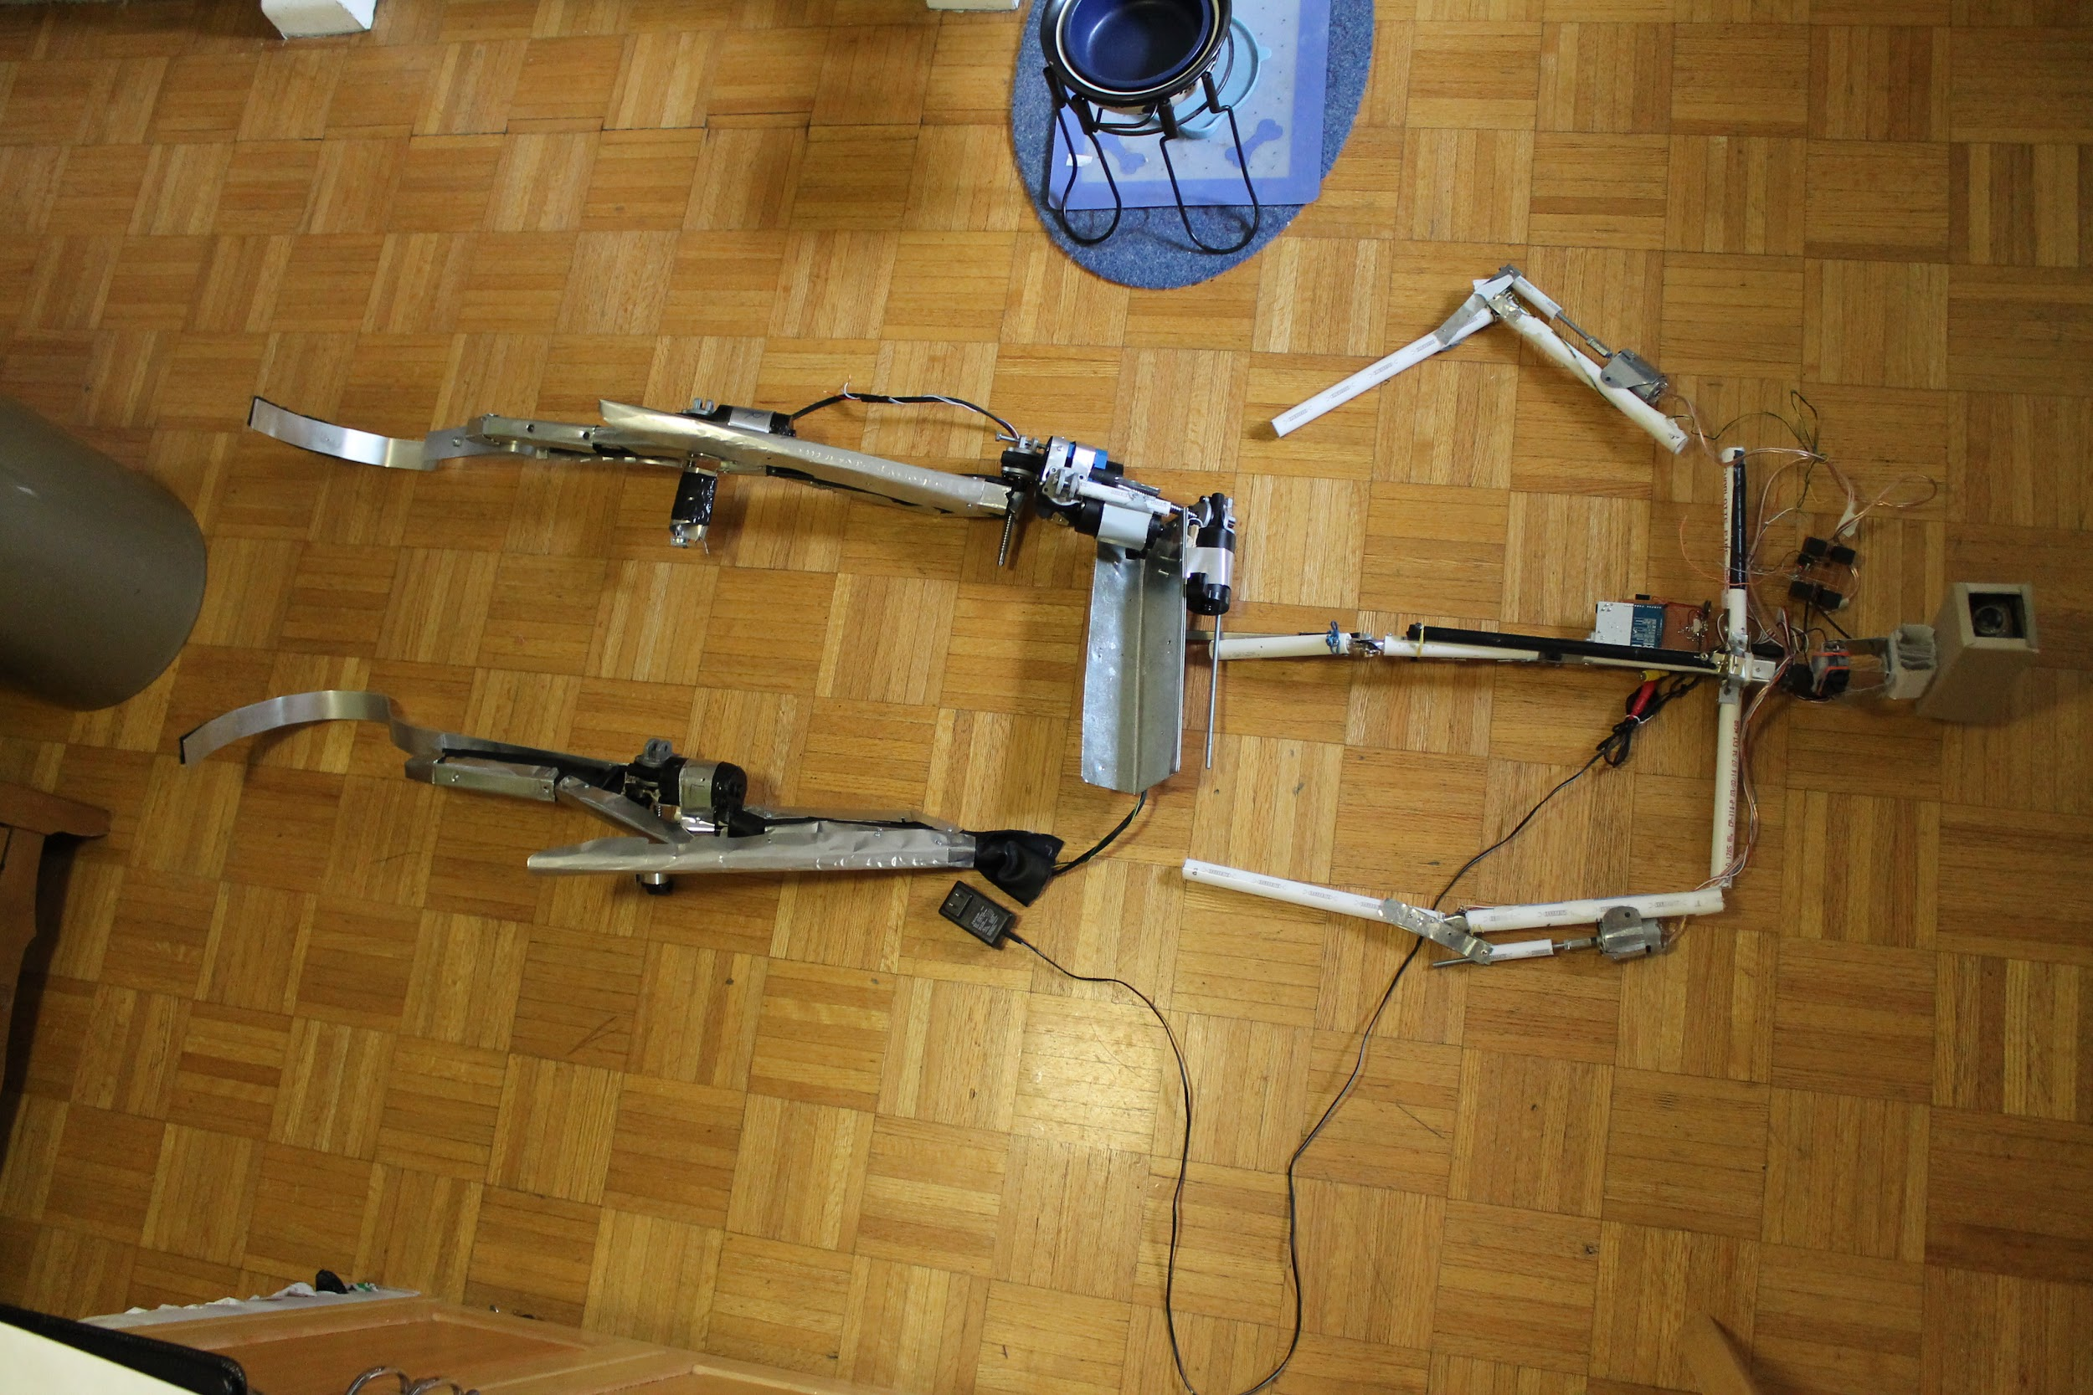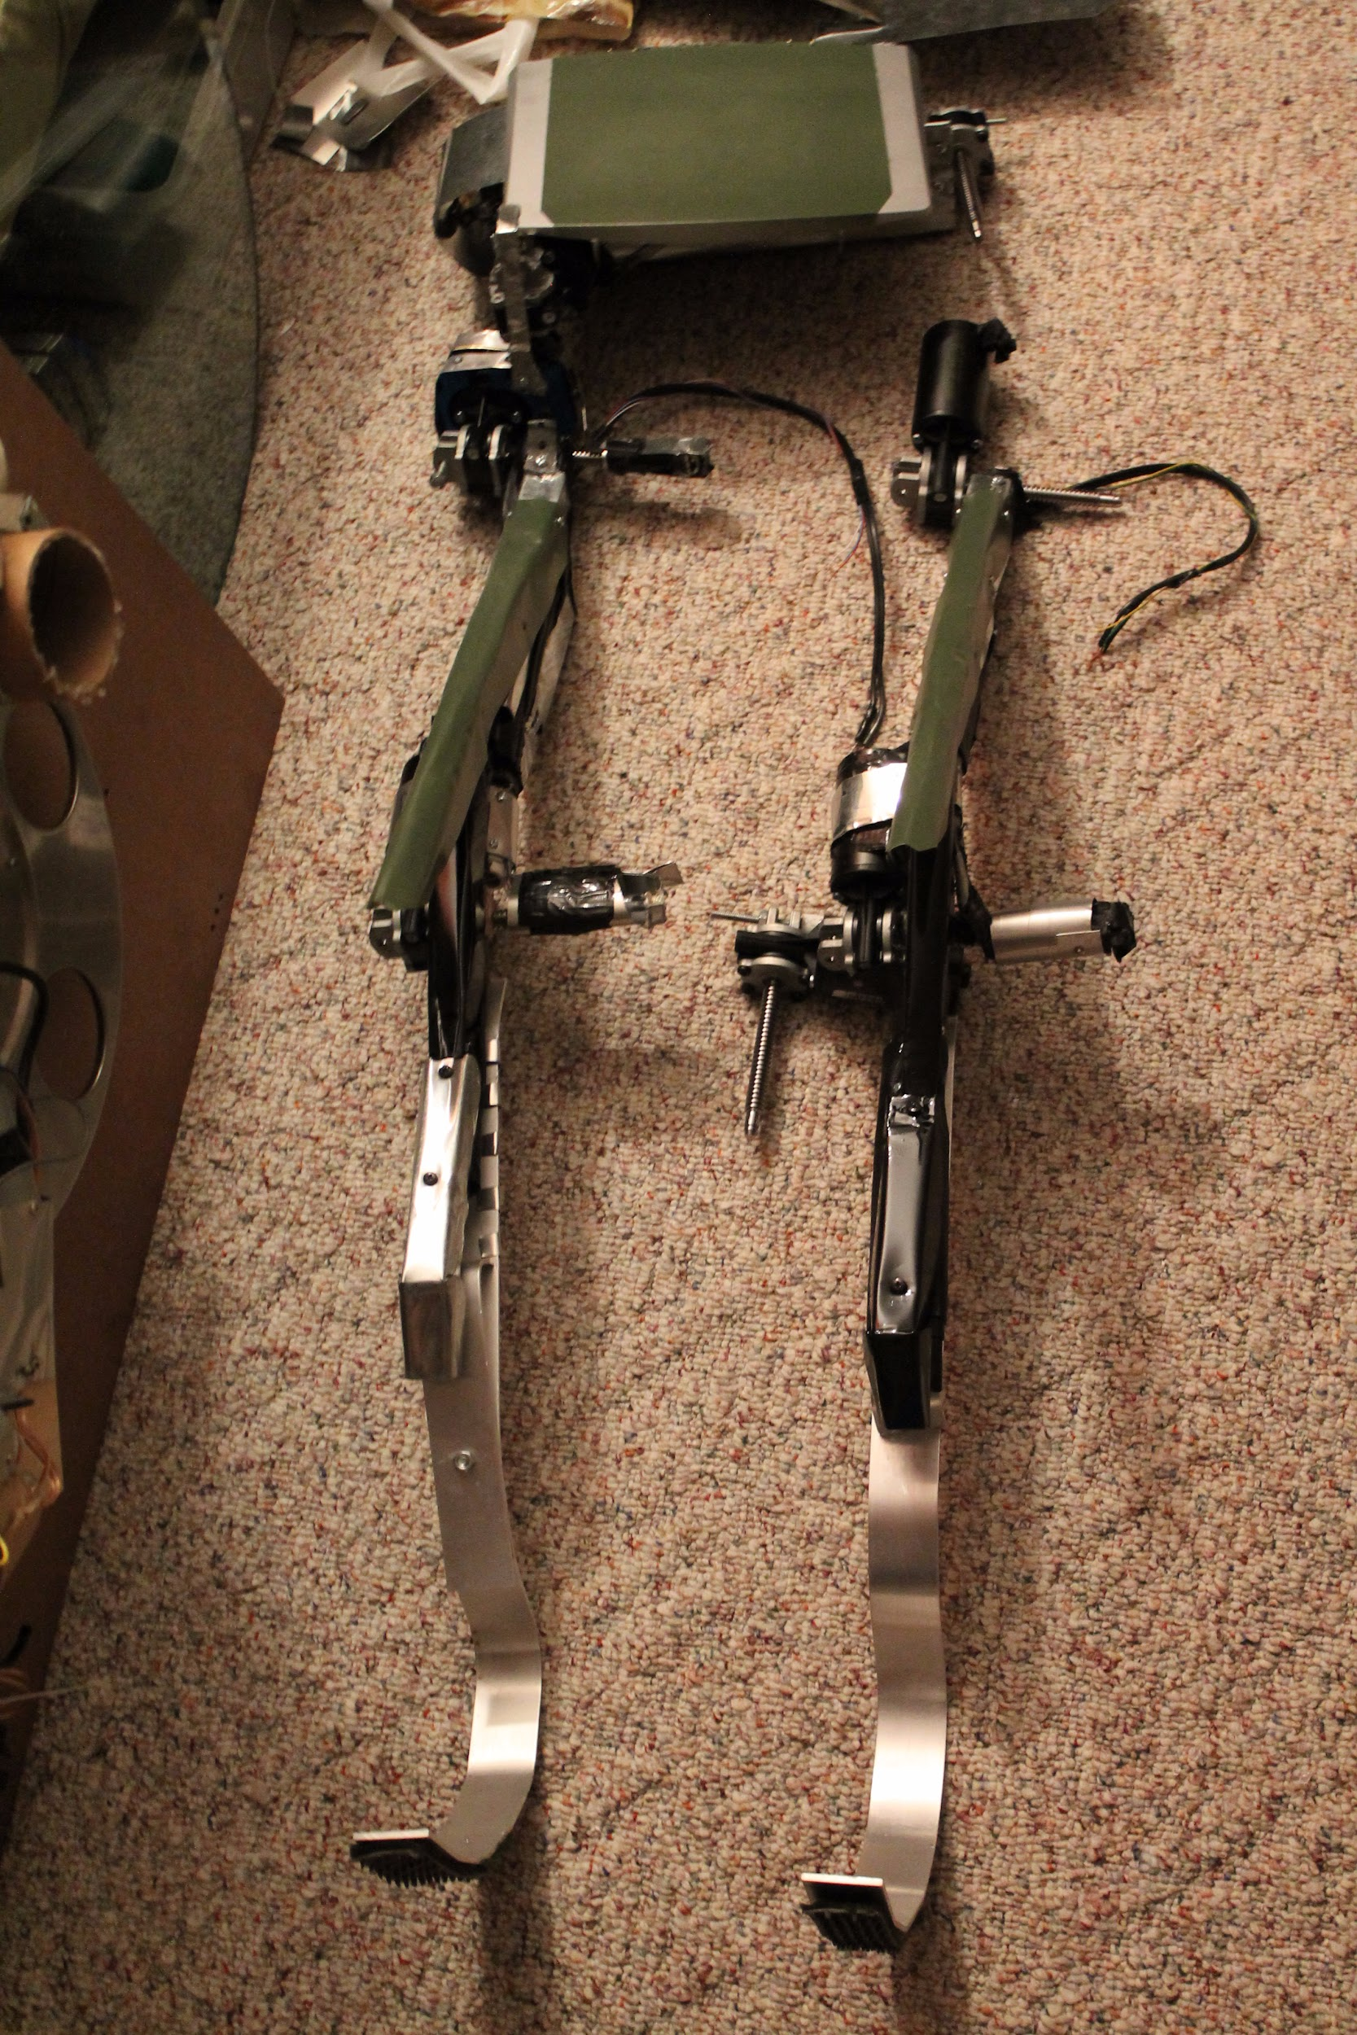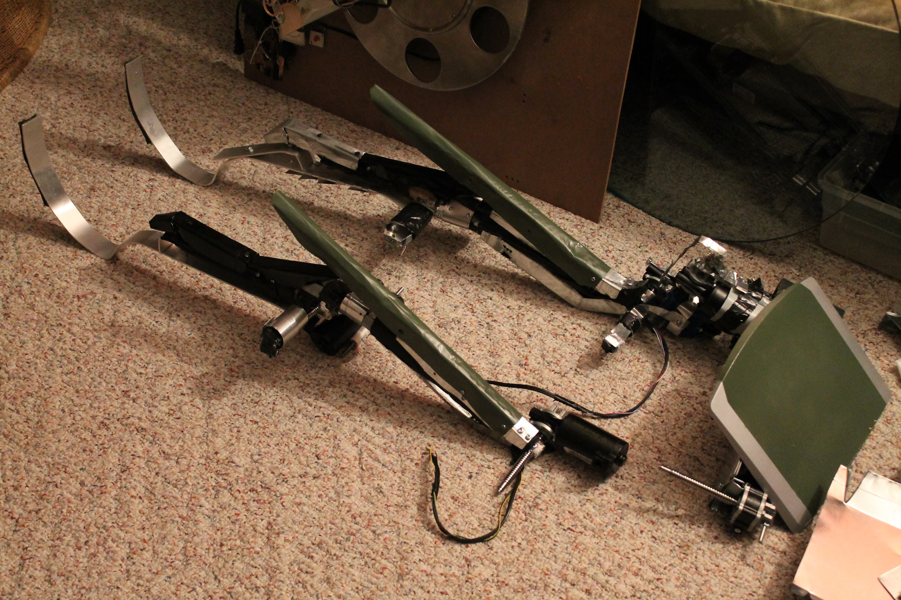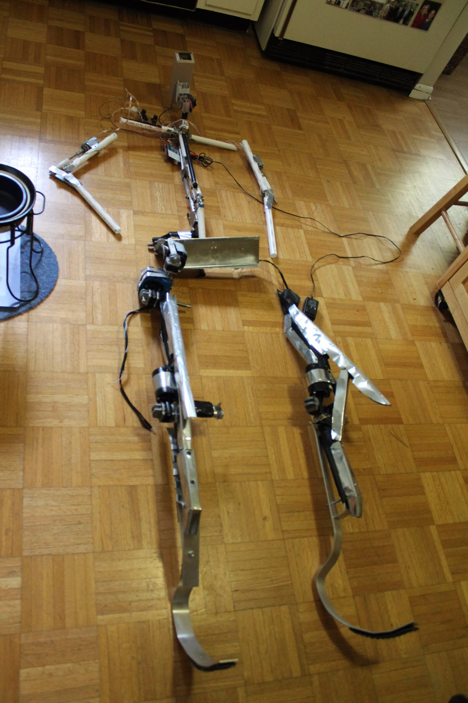

If it could stand it would stand at 6’ - 7”. It would theoretically weigh at least 20 - 30 lbs.

Artist concept rendition:

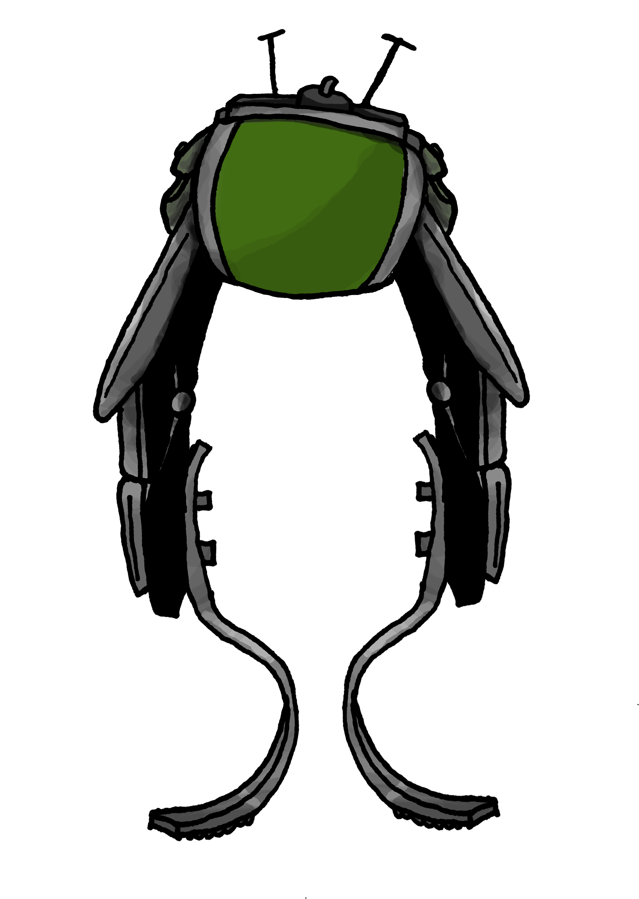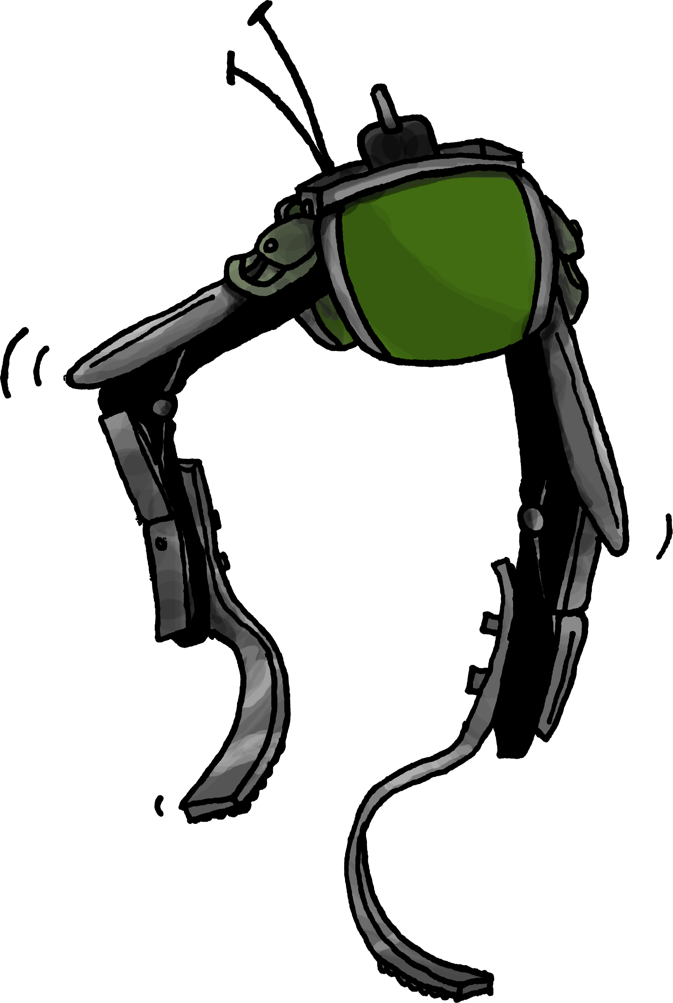

1/21/15
Telepresence Robot v.0.1b

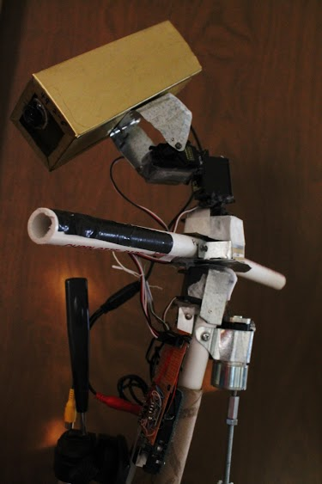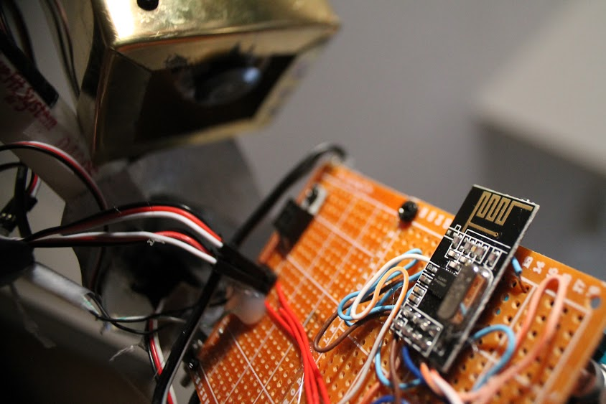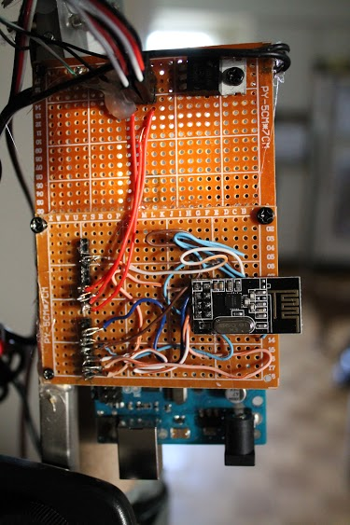
More pictures here…

6/19/14
Oscilloscope Using Composite Video and an Arduino

20140619 Oscilloscope Using Composite Video and an Arduino

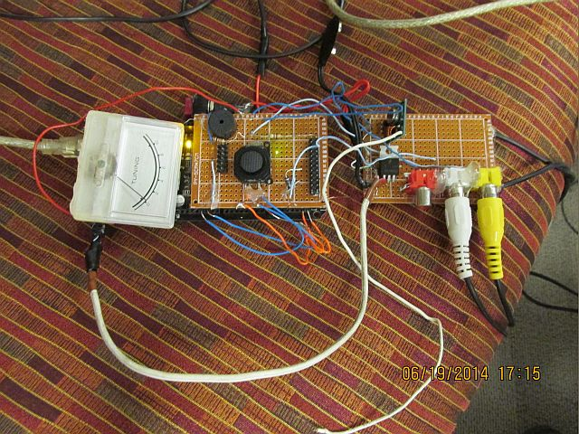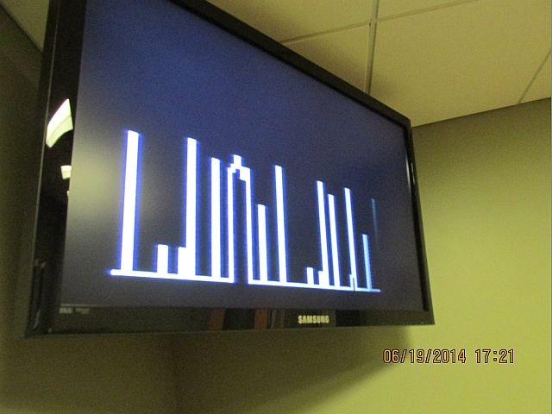

5/22/14
Parallax Propellor


Speech Synthesis
This Propeller Spin project is based on Phil Pilgrim’s Phonemic Speech Synthesis (3rd installment, 7 Nov 2006). This is one of the many resources available from forums.parallax.com.
Phil’s talk object has methods that you can pass addresses of strings to, and the strings represent phonemes. The result is something akin to “text to speech.” The difference is that the object does not analyze actual text and figure out how it is supposed to sound. You have to pass strings (well, actually the addresses of strings) to the object’s say method that describe each word’s phonemes.
Board of education Tutorial

With the D-40 bare bones version use the same code on the tutorial link but change the xinfreq to your crystal value and you will have to attach a speaker to one of the ports.

5/15/14
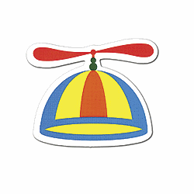
Parallax Propellor
The Propeller chip is a multi core microcontroller that is programmable in high-level languages (Spin™ and C) as well as a low-level (Propeller assembly) language. Application development is simplified by using the set of pre-built objects for video (NTSC/PAL/VGA), mice, keyboards, LCDs, stepper motors and sensors.
The Propeller is designed with an emphasis on general-purpose use, with powerful capabilities that are great for customized high-speed embedded processing, while maintaining low power, low current consumption and a small physical footprint. The Propeller's processors are all identical, each with its own separate memory, and each with an identical interface to all 32 I/O pins and internal shared memory. The architecture is built for swift processing of asynchronous events, equal access to internal and external resources, and dynamic speed and power when it's needed.
The P8X32A-D40 is most useful for prototyping in breadboarded or socketed circuits. The Propeller is easily connected to your computer's serial or USB port for programming using our Prop Plug. The Propeller chip can run on its own with a 3.3-volt power supply, internal clock, and with its internal RAM for code storage. Add an external EEPROM for non-volatile code storage and an external clock source for accurate timing.
Key Features:
- Multicore processing simplifies designs subject to asynchronous requirements
- DIP package for easy prototyping with a breadboard
- Built-in Spin language is easy to learn
- PropGCC support provides a familiar feel for C/C++ programmers
- Propeller Assembly language supports deterministic timing using single-path, multi-decision techniques
- Internal or external clock sources provide flexible speed options
Buy It At Microcenter!
Setup Circuit
Download Tools

3/6/14

FinOS v.0.71a
Schematic
Parts List

WARNING!!!


With 12,000 lines of code and very little documentation, this is serious spaghetti code. In a later version I will add documentation and several different versions with several choosable hardware configurations. To get an idea of this look here.

